Instructions manual to

JB-L6 Tissue Embedding & Cooling System

Attention: Before using the machine, please read this Instruction carefully, and keep the Instruction for further reference.

WUHAN JUNJIE ELECTRONICS CO., LTD

Address：Chuangye Street 10-A-404, Guanggu, East Lake High-tech Development Zone, Wuhan City
Postcode：430074
Tel: 8627-87401756 / 862787411993 Fax:8627-87411993
Website：http://www.whjjbl.com E-mail： junjiedianzi@126.com

Foreword

JB-L6 biological tissue embedding machine instruction
is the implementation of the instructions for use-general conditions of the national standards for industrial products, in accordance with the instruction package of regulations on the management of the development of medical devices.

It explains the performance, structure, methods and the use of the product life, product labels, graphics, symbols, logos and other content.

Tissue embedding machine ages 6 years

1. Purpose
JB-L6 biological tissue embedding machine is suitable forparaffin-embedded tissue which after losing. In hospitals, medical colleges and scientific research units and sectors such as food inspection, animal and plant have been widely used.

The machine controlled by SCM. Major soluble wax cylinders, insulating cylinder, electric nozzles, temperature control table, heating devices and other components.

2. Considerations
1. Before turn the machine on, wax cylinders required right amount of medical wax. Dry firing is strictly prohibited.
2. The temperature value should be in the context of wax melting point during use.
3. Before the paraffin not completely melted, do not operate "a wax switch" (proximity switches, foot switches) to avoid damage to your equipment.
4. Prohibits water or other liquid spills into this box, wax cylinders should not be included any other debris
5，Power on the heating process, the soluble wax cylinder head can not be opened. (Wax temperature reaches 60 ° c-65 ° c for about 40 minutes.)
6. To prevent the impurities entering the wax cylinder to avoid wax of the stream mouth plug
7. The power socket is properly grounded
8. Non-professional workers do not disassemble, otherwise bear the consequences.

3. Main technical parameters
1、Wax cylinder temperature preset range：0～99℃
Precision temperature control：±2℃
2、Insulation cylinder temperature preset range：0～99℃
Precision temperature control：±2℃
3、Table of temperature control range：0～99℃
Precision temperature control：±2℃
4、Tweezers temperature control range：0～99℃
Precision temperature control：±2℃
5、Wax tube set temperature defaults to 68 ° c
6、Wax cylinder capacity: 3000ml
7、Stream wax works: proximity switch control, foot switch control
8、Preset time: you can set boot and shutdown in a week time
9、Cold temperature setting 0 – 35 ° c.
10、Compressor operating mode, each time the on/off, wait 10 minutes for the second time.
Initial power on and wait 10 minutes. (Whether or not it is powered, time will decrease)
11、Power supply voltage：AC220V±10％
12、Power supply frequency：501Hz
四、Operation
Initial power on, first screen is displayed on the LCD screen as follows:

Equipment started working after 5 seconds automatically display a second LCD screen
1. Second screen of menu key frame:
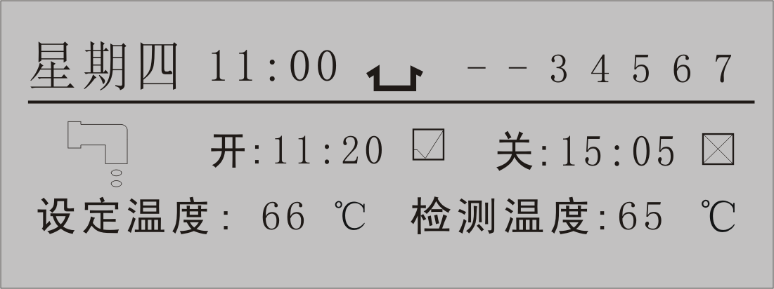
2、Third screen
1）Press the "+" or "-" key anti-white cursor to ┗ ┛ press "confirm" button, the LCD display screen IV as follows:
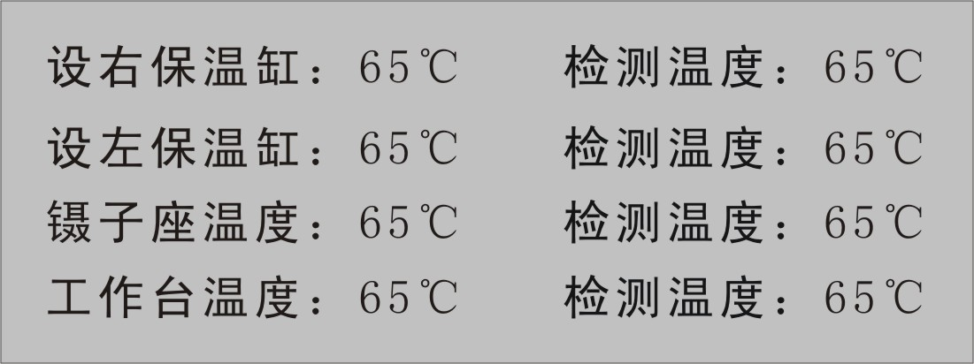
Press "menu" key to return to the second screen。
2）When the LCD display screen IV images：
Press the "+" or "-" key anti-white cursor to select the parameters that can be adjusted as follows：
Right insulation cylinder：65℃
Left insulation cylinder：65℃
Tweezers set temperature：65℃
Bench set temperature：65℃

After selecting one of the four, press "confirm" button, anti-white cursor blinking, press the "+" or "-" keys set the temperature value.

Press "confirm" button, automatically save the latest setting temperature value, or do not press "confirm" button, automatically save the latest setting temperature value after 3S.
Press "menu" key to return.

3、Second screen operation method：
Press the "+" or "-" key anti-white will move the cursor to select:
Work date（1，2，3，4，5，6，7）
Power-on time (hours, minutes)
Shutdown time (hours, minutes)
Wax cylinder set temperature
Select one of five press "confirm" button, anti-white cursor blinking, press the "+" or "-" button, adjust the setting corresponds to the parameter value, press the "confirm" button, automatically save the latest setting temperature value, or do not press "confirm" button, automatically save the latest setting temperature value after 3S.

Work date (1, 2, 3, 4, 5, 6, 7) only need to press the "confirm" button, select the enable or cancel. Cancelling dates into the "-". For example: (1, 2, 3, 4, 5,-,-), said on Saturday, does not work on Sundays.

When the symbol appears underneath the wax dripping wax mouth, and means that the device is working correctly. If there are no wax dripping symbol appears, indicates that the system is heated, does not work.
4、☑ or ☒
When the scheduled power on/off function available：
☑ Represent the current boot or shutdown time status effective;
☒ Represent the current boot or shutdown time in an invalid state.
5、Timer function：
Native calculated 7 days on the scheduled date.
(Please note).
On a cold bench operation method and

4. Output status：

1、When wax cylinder testing when the temperature is equal to the set temperature, heating stops, when the wax cylinder temperature is below the set temperature within 2 ° c is detected, open heating. Less than 3 ℃ when opening heat.

2、Waxes, wax valve heating for half heating. When the temperature reached 67 degrees stop heating, heating condition: only when the wax cylinder temperature is heated to below the set temperature 3 ° c, heating until. Note: wax, wax valve temperature values cannot be modified.

3、Wax valve manual control switch and foot switch operating conditions: only when the wax cylinder temperature heating to a temperature 2 ° c below the set, can be controlled. Candle wax dripping mouth symbol appear simultaneously.

4、Flow control valve: wax valve manual control switch and foot switch can work when wax flow Chu, adjustable flow valves.

5. Maintenance：

A. When the machine when there is no power, check the 220V power outlet fuse is intact.

B. When the detection temperature Chu "Err" symbol, said Chu is the temperature sensor fault. While the corresponding heating element stops heating. Need to replace the temperature sensor.

C. When the heating element does not heat, first check that the set temperature is correct. Then check the heating element and circuit.

PACKING LIST

JB-L6
Host (cold) 1 PCS
Foot switch 1 PCS
FUSE (3 a-6A) 2 PCS
Power cord 2 PCS
Embedding box 1 PCS
Manual 1 PCS
Product certification 1 PCS
Service feedback form 1 PCS
Inspection report form 1 PCS
Packing slip 1 PCS

Service feedback form
USER |  | MACHINE #
SALES |  | CONTRACT #
OPENER |  | OPEN DATE
Your satisfaction with the service:
Very satisfied □ satisfied □ Not satisfied □ mark“√”
Power on issues and feedback

1、Upon opening the box the machine for damage, random files and spare parts, accessories are completed

2、Using methods and points for attention of the machines, operations (installation) people speak clearly?

3、Where you think this machine also has shortcomings, recommendations on the machine?

Customer signature：
Date:
After you completed the form, fit the personnel back to sent mail or fax back to become registered users of our products.

Equipment installation and inspection reports
Machine name |  |  |  |  |  | Machine #
User name |  |  |  |  |  | User add.
using  Dept. |  |  |  | superviser |  |  | Tel.
 |  |  |  | user |  |  | Tel.
Arriving date |  |  |  |  |  | Contract #
Installation | Equipment installation and commissioning works, specifications meet the specification requirements can be delivered using  Installing signature:  Date:
Acceptance conditions | Instrument package good, complete accessories, normal, specification meets the specification requirements, confirm the acceptance of our unit.  Dept. signature: Hospital Chop:  Date:
武汉俊杰电子有限公司
TEL：027-87401756 87411993 FAX：027-87411995
WEBSITE：www.whjjbl.com
E-mail：junjiedianzi@126.com ZIP CODE：430074
ADDRESS：武汉市东湖新技术开发区武大科技园兴业楼北楼二单元1203

